 All Saints Lutheran Church

Pastor Eric S. Aune

Pastor Matthew Schroeder

Darcy Gray, Office Administrator

Patrick & Jacqueline Bencke, Missionaries – Japan

___________________________________________________ ________________

Season of Pentecost __ ______ October 17, 2021

Prelude

Welcome and Announcements

Sunday School Story - James and John

Children’s Offering “Sanctuary”

Lord, prepare me to be a sanctuary

Pure and holy, tried and true

With thanksgiving I’ll be a living sanctuary for you.

3rd Grade Bible Blessing (9 am)

**Confession and Forgiveness**

L: Blessed be the holy Trinity, one God, who is eager to forgive and who loves us beyond our days. Amen. Dear friends, together let us acknowledge our failure to love this world as Jesus does.

God of mercy and forgiveness,

**All: We confess that sin still has a hold on us. We have harmed your good creation. We have failed to do justice, love kindness, and walk humbly with you. Turn us in a new direction. Show us the path that leads to life. Be our refuge and strength on the journey, through Jesus Christ, our redeemer and friend. Amen.**

L: Beloved of God: your sins are forgiven, and you are made whole. God points the way to new life in Christ, who meets us on the road. Journey now in God's abiding love through the power of the Holy Spirit.

**All: Amen.**

Gathering Hymn "Christ Be Our Light" Verses 1, 2, 5 #715

1. Longing for light, we wait in darkness.

Longing for truth, we turn to you.

Make us your own, your holy people,

light for the world to see

Refrain:

Christ, be our light! Shine in our hearts.

Shine through the darkness.

Christ be our light!

Shine in your church gathered today.

2. Longing for peace, our world is troubled.

Longing for hope, many despair.

Your word alone has pow'r to save us.

Make us your living voice. (Refrain)

5. Many the gifts, many the people,

many the hearts that yearn to belong.

Let us be servants to one another,

signs of your kingdom come. (Refrain)

Text: Bernadette Farrell, b. 1957

Music: Bernadette Farrell

Text and music © 1993 Bernadette Farrell, admin. OCP Publications

Kyrie #157

Leader: In peace, in peace, let us pray to the Lord

**Congregation: Lord, have mercy.**

**Christ, have mercy.**

**Lord, have mercy.**

L: For the reign of God,

and for peace throughout the world,

for the unity of all,

Let us pray to the Lord.

**C: Lord, have mercy.**

**Christ, have mercy**

**Lord, have mercy.**

L: For your people here

who have come to give you praise,

for the strength to live your word,

let us pray to the Lord.

**C: Lord, have mercy.**

**Christ, have mercy.**

**Lord, have mercy.**

L: Help, save, and defend us, O God.

**C: Amen.**

Text: Lutheran Book of Worship, adapt. Mary Haugen. B. 1950

Music: Now the Feast and Celebration, Mary Haugen

Text and music © 1990 GIA Publications, Inc.

Canticle of Praise "Now the Feast and Celebration" #167

Refrain:

Now the feast and celebration,

All of creation sings for joy

To the God of life and love and freedom;

Praise and glory for evermore.

Now is the feast of the Lamb once slain,

Whose blood has freed and united us

To be one great people of God. (Refrain)

Power and riches, wisdom and might,

All honor and glory to Christ forever. (Refrain)

For God has come to dwell with us,

To make us people of God;

To make all things new. (Refrain)

Text and music: Marty Haugen, b. 1950

Text and music © 1990 GIA Publications, Inc.

**Prayer of the Day**

L: Lord Jesus,

**C: help us to hear your call in our lives, and when we hear, help us to say yes. Give us the grace to see the tasks to which you call us as your disciples. Then give us the gifts we need to accomplish those tasks for you. We marvel that you have placed us within your kingdom. At times we feel inadequate, unequal to the task you have given us. Nevertheless, help us to delight in your will, to walk in your way, and to enjoy the privilege of serving you in this time and place. Amen.**

**Word**

First Reading Isaiah 53:4-12

The fact is, it was *our* pains he carried—  
    *our* disfigurements, all the things wrong with *us.*  
We thought he brought it on himself,  
    that God was punishing him for his own failures.  
But it was our sins that did that to him,  
    that ripped and tore and crushed him—*our sins*!  
He took the punishment, and that made us whole.  
    Through his bruises we get healed.  
We’re all like sheep who’ve wandered off and gotten lost.  
    We’ve all done our own thing, gone our own way.  
And God has piled all our sins, everything we’ve done wrong,  
    on him, on him.

**7-9**He was beaten, he was tortured,  
    but he didn’t say a word.  
Like a lamb taken to be slaughtered  
    and like a sheep being sheared,  
    he took it all in silence.  
Justice miscarried, and he was led off—  
    and did anyone really know what was happening?  
He died without a thought for his own welfare,  
    beaten bloody for the sins of my people.  
They buried him with the wicked,  
    threw him in a grave with a rich man,  
Even though he’d never hurt a soul  
    or said one word that wasn’t true.

**10**Still, it’s what God had in mind all along,  
    to crush him with pain.  
The plan was that he give himself as an offering for sin  
    so that he’d see life come from it—life, life, and more life.  
    And God’s plan will deeply prosper through him.

**11-12**Out of that terrible travail of soul,  
    he’ll see that it’s worth it and be glad he did it.  
Through what he experienced, my righteous one, my servant,  
    will make many “righteous ones,”  
    as he himself carries the burden of their sins.  
Therefore I’ll reward him extravagantly—  
    the best of everything, the highest honors—  
Because he looked death in the face and didn’t flinch,  
    because he embraced the company of the lowest.  
He took on his own shoulders the sin of the many,  
    he took up the cause of all the black sheep.

L: The Word of the Lord

**C: Thanks be to God**

Gospel Mark 10:35-45

35 James and John, Zebedee’s sons, came up to him. “Teacher, we have something we want you to do for us.”

36 “What is it? I’ll see what I can do.”

37 “Arrange it,” they said, “so that we will be awarded the highest places of honor in your glory—one of us at your right, the other at your left.”

38 Jesus said, “You have no idea what you’re asking. Are you capable of drinking the cup I drink, of being baptized in the baptism I’m about to be plunged into?”

39-40 “Sure,” they said. “Why not?”

Jesus said, “Come to think of it, you will drink the cup I drink, and be baptized in my baptism. But as to awarding places of honor, that’s not my business. There are other arrangements for that.”

41-45 When the other ten heard of this conversation, they lost their tempers with James and John. Jesus got them together to settle things down. “You’ve observed how godless rulers throw their weight around,” he said, “and when people get a little power how quickly it goes to their heads. It’s not going to be that way with you. Whoever wants to be great must become a servant. Whoever wants to be first among you must be your slave. That is what the Son of Man has done: He came to serve, not to be served—and then to give away his life in exchange for many who are held hostage.”

L: The gospel of the Lord

**C: Praise to you O Christ**

Hymn of the Day "Lord, Whose Love in Humble Service" Verses 1 & 3 #712

1. Lord, whose love in humble service

Bore the weight of human need.

Who upon the cross, forsaken

Worked your mercy’s perfect deed:

We, your servants, bring the worship

Not of voice alone, but heart;

Consecrating to your purpose

Every gift which you impart.

3. As we worship, grant us vision,

Till your love’s revealing light

In its height and depth and greatness

Dawns upon our quickened sight,

Making known the needs and burdens

Your compassion bids us bear,

Stirring us to ardent service,

Your abundant life to share.

Text: Albert F. Bayly, 1901-1984

Music: The Sacred Harp, Philadelphia, 1844: arr. Selected Hymns, 1985

Text © Oxford University Press

Music © 1985 Augsburg Fortress

Sermon

Offering

**Offertory Prayer**

L: Let us pray together.

**All: Our church is composed of people like me. I help make it what it is. It will be friendly, if I am. Its chairs will be filled, if I help fill them. It will do great work, if I work. It will make generous gifts to many causes, if I am a generous giver. It will bring other people into its worship and fellowship, if I invite and bring them. It will be a church where people grow in faith and serve you, if I am open to such growth and service. Therefore, with your help Lord, we shall dedicate ourselves to the task of being all the things you want your church to be. Amen.**

Words of Institution

Lord's Prayer

Communion

Blessing

Prayer

**Benediction**

L: May the God of hope fill us with the power of the Holy Spirit so that we will: Celebrate

**C: Grace**

L: Make

**C: Disciples**

L: Make

**C: A Difference**

L: Because

**C: We are All Saints - All the Time! Amen.**

Sending Hymn "We Are Called" #720

1. Come! live in the light!

Shine with the joy and the love of the Lord!

We are called to be light for the kingdom,

to live in the freedom of the city of God!

Refrain:

We are called to act with justice.

We are called to love tenderly.

We are called to serve one another, to walk humbly with God.

2. Come! Open your heart!

Show your mercy to all those in fear!

We are called to be hope for the hopeless,

so all hatred and blindness will be no more! *Refrain*

3. Sing! Sing a new song!

Sing of that great day when all will be one!

God will reign and we'll walk with each other

as sisters and brothers united in love! *Refrain*

Text: David Haas, b 1957

Music: David Haas

Text and music © GIA Publications, Inc.

L: Go in peace. Serve the Lord.

**C: Thanks be to God.**

Accompanist: Jane Fasching

**WELCOME TO ALL SAINTS**

*We are glad you chose to worship at All Saints today. We hope you find the worship service meaningful and that you feel at home with our congregation. If you want to learn more about All Saints or are looking to be connected, visit* [*www.allsaintsnya.org*](http://www.allsaintsnya.org) *or contact one of our staff:*

*Darcy Gray, Office Administrator* [*dgray@allsaintsnya.org*](mailto:dgray@allsaintsnya.org)

*Pastor Eric Aune* [*eaune@allsaintsnya.org*](mailto:eaune@allsaintsnya.org)

*Pastor Matthew Schroeder* [*mschroeder@allsaintsnya.org*](mailto:mschroeder@allsaintsnya.org)

**Remember in Prayer**

Justin Nelson for healing

Pete & Adie Hegrenes for healing

Eric & Judy’s niece’s husband Robert for healing

Mark Jungclaus for healing

Carol Sandbo for healing

Nate and Laura Aune’s infant daughter, Margo for healing

Dick Docken for healing

Nelda Duenow for healing

Brian Foster for healing

Laurie Hilgers’ father for peace and comfort

Cassie Storms for healing

Kassie Harms for healing

Andrew Haley stationed in Virginia

**National Youth Gathering Registration**

The largest group All Saints ever sent to a National Youth Gathering was 35 youth. We can break that record this coming year as the gathering is in our backyard—US Bank Stadium. Your child will not want to miss this life-changing opportunity. ***Registration is due now along with your $150.00 non-refundable deposit.***

**All Saints Quilting group will now be the Crafter’s Group**

The Crafters meet Tuesdays, October 19 and November 2, 16, & 30 from 10:00 am – 4:00 pm. Bring your own craft and a lunch for yourself. If you can’t stay all day, that’s just fine. Come when you and want and leave when you need to.

**Trunk or Treat - October 25 6:30 - 7:30 pm**

Here is a fun and safe way to trick or treat. Bring your costumed children to the church parking lot where they can stop at decorated cars and pick up a treat or prize. This event is open to the public, invite your friends.

Trunk or Treat Vehicle Participants:

We need participants to help by decorating the trunk of your car or back end of trucks or SUVs which we will park at the west end of the parking lot. We ask that you bring candy or prizes to hand out to the kids who come around. We are also going to ask congregation members to donate candy or prizes. Pick up a flyer at the Welcome Center for more detailed information. New this year we will be inside the building too. You can decorate a “trunk” space in the church and hand out candy there (space limited). Sign up at the Welcome Center or email [dgray@allsaintsnya.org](mailto:dgray@allsaintsnya.org) to reserve a space either in the parking lot or inside.

**Congregation: If you don't want to decorate a vehicle you can help by donating candy or small prizes to hand out. There is tub outside the offices for donations.**

**College and Military Care Packages**

Our 6th and 7th grade Confirmation students will assemble care packages on Wednesday, Oct. 27 to go to our college students and active military. Your donations are appreciated: money to help pay postage, items to go in the packages such as: candy, gum, ramen noodles, popcorn and other microwave foods, pens, pencils, highlighters, trial size health and beauty, anything else you think a college student or active military person would enjoy. Please bring items in or make your monetary donations by October 24. Items can go in the box outside the offices. Monetary donations, labeled “care packages”, can be placed in the offering plate or in Darcy's office.

If you have a college student or an active military person in your family, please leave a note on Darcy's desk or email their address to Darcy [dgray@allsaintsnya.org](mailto:dgray@allsaintsnya.org) . Because we pre-purchase mailing boxes from the post office, we will be unable to send packages to addresses received after October 24.

**Annual Mens Pancake Breakfast**

The All Saints Mens annual pancake breakfast is Sunday, October 31. Serving will be from 8:30 -11:30 am. We'll have pancakes, sausage, ham, juice and coffee. A free will offering will be taken. Men please sign up at the Welcome Center to help.

**Game Dinner**

Delicious food awaits you on Tuesday, November 2 from 6:00 - 7:00 pm at our annual game dinner. Sign up at the Welcome Center and let us know if you have a favorite dish to share. All are invited and you do not have to be a hunter or bring wild game to enjoy the evening.

**“Being Present: A Soul’s Journey” an adult forum led by Tim Sauer**

Sunday, November 7 & 14 9:00 – 9:50 am

Have you ever wondered about: a) How do we know that we have a soul? b) Why are we here? C) What can I do/be to make more of my life each and every day?

Using stories, comfortable discussion groups and spirited conversations, we will discover together new ways to be more present in our daily lives. Sign up at the Welcome Center

**Farewell Celebration**

We will gather together on November 21st to surround Eric, Judy, and the rest of the Aune family with love and gratitude as we give thanks for 40 years of ordained ministry. At 8:00, 9:00, & 10:15 am, Bishop Ann Svennungsen of the Minneapolis Area Synod will be with us in worship for a Blessing of Godspeed to Pastor Eric. Join us for donuts and coffee before each worship service and a catered lunch from Hillcrest at 11:00 am. Pastor Eric’s last worship service will be December 24th so there will be plenty of time to wish him well in his retirement. We hope you will help us thank Pastor Eric and the Aune family for 36 years of faithful service to All Saints Lutheran Church.

To make reservations for the lunch, please fill out the reservation card in your bulletin.

**The Week Ahead:**

Sun Oct 17 Worship and communion at 8:00, 9:00 & 10:15 am

9:00 & 10:15 am Sunday School

9:00 am 3rd grade receive bibles and Bible 101

Mon Oct 18 7:00 pm New Member Orientation at Pastor Eric & Judy’s

Tues Oct 19 6:30 pm Church Council

Wed Oct 20 No Activities

Thurs Oct 21 8:00 pm AA

Sun Oct 24 Worship at 8:00, 9:00 & 10:15 am

9:00 & 10:15 am Sunday School

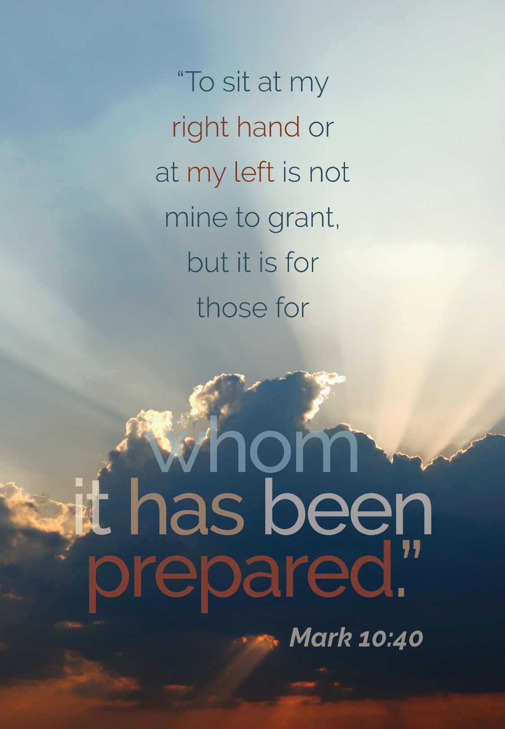

**October 17, 2021**

**Worship at 8:00, 9:00 & 10:15 am**

**All Saints Lutheran Church**

**511 N. Merger Street, P.O. Box 550**

**Norwood Young America, MN 55368**

**952-467-3388**

[**www.allsaintsnya.org**](http://www.allsaintsnya.org)