 All Saints Lutheran Church

Pastor Matt Schroeder

Darcy Gray, Office Administrator

Patrick & Jacqueline Bencke, Missionaries – Japan

______________________________________________________________ _____

Third Sunday after Epiphany ______ January 23, 2022

*Please feel free at any time to use the red ELW hymnal under the seat in front of you.*

Welcome and Announcements

Children’s Time “Jesus Goes to Nazareth” (9 am)

Baptism (10:15 am)

**Call to Worship**

L: The Spirit of the Lord is upon us.

**C: The Spirit of the Lord is in us.**

L: Anointing us.

**C: Sending us.**

L: To bring good news.

**C: To bind up.**

L: To proclaim favor.

**C: To comfort.**

L: To provide.

**C: To loosen.**

C: The day of the Lord is coming.

**L: The day of the Lord has come.**

**Confession and Forgiveness**

L: If we say we are completely put together, the truth is not in us.

**C: But if we confess our distractions, our errors, and our anxieties, God will meet us and renew us. Before God and God’s people, I confess that I have been reluctant to speak out clearly, naming the injustice I see and declaring God’s vision.**

**Before God and one another, we confess our reluctance to receive our calling as God’s people, made by God and chosen as witnesses to God’s dream of justice and joy.**

**Remind me, God, that you have made me for your service and recharge me with your Word. Renew us, God. Grant us courage to live out your Way of peace and grace.**

**We ask it in Jesus’ name; Amen.**

L: God has promised that whenever we repent and seek a new union with God, forgiveness is ours. That promise comes true now. As a called and ordained minister of the church of Christ and by his authority, I therefore declare to you the entire forgiveness of your sins, in the name of the Father, and of the Son, and of the Holy Spirit. Sisters and brothers, know that in Christ Jesus, we are forgiven.

**C: Thanks be to God! Amen.**

Gathering Hymn **“**Oh, For a Thousand Tongues to Sing” ELW #886

1. Oh, for a thousand tongues to sing  
my great Redeemer's praise,  
the glories of my God and King,  
the triumphs of his grace!

2. My gracious Master and my God,  
assist me to proclaim,  
to spread through all the earth abroad  
the honors of your name.

3. The name of Jesus charms our fears

And bids our sorrows cease,

Sings music in the sinner’s ears,

Brings life and health and peace.

4. He speaks, and listening to his voice

new life the dead receive;

the mournful, broken hearts rejoice

the humble poor believe.

5. Look unto him, your Savior own,

O fallen human race!

Look and be saved through faith alone,

Be justified by grace!

6. To God all glory, praise, and love

Be now and ever given

By saints below and saints above,

The church in earth and heaven.

*Public Domain*

**Prayer of the Day**

**All:** **Blessed Lord God, you have caused the holy scriptures to be written for the nourishment of your people. Grant that we may hear them, read, mark, learn, and inwardly digest them, that, comforted by your promises, we may embrace and forever hold fast to the hope of eternal life, through your Son, Jesus Christ our Savior and Lord. Amen.**

**Reading** 1 Corinthians 12:12-31a (NRSV)

**12**For just as the body is one and has many members, and all the members of the body, though many, are one body, so it is with Christ. **13**For in the one Spirit we were all baptized into one body—Jews or Greeks, slaves or free—and we were all made to drink of one Spirit.

**14**Indeed, the body does not consist of one member but of many. **15**If the foot would say, “Because I am not a hand, I do not belong to the body,” that would not make it any less a part of the body. **16**And if the ear would say, “Because I am not an eye, I do not belong to the body,” that would not make it any less a part of the body. **17**If the whole body were an eye, where would the hearing be? If the whole body were hearing, where would the sense of smell be? **18**But as it is, God arranged the members in the body, each one of them, as he chose. **19**If all were a single member, where would the body be? **20**As it is, there are many members, yet one body. **21**The eye cannot say to the hand, “I have no need of you,” nor again the head to the feet, “I have no need of you.” **22**On the contrary, the members of the body that seem to be weaker are indispensable, **23**and those members of the body that we think less honorable we clothe with greater honor, and our less respectable members are treated with greater respect; **24**whereas our more respectable members do not need this. But God has so arranged the body, giving the greater honor to the inferior member, **25**that there may be no dissension within the body, but the members may have the same care for one another. **26**If one member suffers, all suffer together with it; if one member is honored, all rejoice together with it. **27**Now you are the body of Christ and individually members of it. **28**And God has appointed in the church first apostles, second prophets, third teachers; then deeds of power, then gifts of healing, forms of assistance, forms of leadership, various kinds of tongues. **29**Are all apostles? Are all prophets? Are all teachers? Do all work miracles? **30**Do all possess gifts of healing? Do all speak in tongues? Do all interpret? **31**But strive for the greater gifts. And I will show you a still more excellent way.

**Gospel** Luke 4:14-21 (NRSV)

**14**Then Jesus, filled with the power of the Spirit, returned to Galilee, and a report about him spread through all the surrounding country. **15**He began to teach in their synagogues and was praised by everyone.

**16**When he came to Nazareth, where he had been brought up, he went to the synagogue on the sabbath day, as was his custom. He stood up to read, **17**and the scroll of the prophet Isaiah was given to him. He unrolled the scroll and found the place where it was written:

**18**“The Spirit of the Lord is upon me, because he has anointed me to bring good news to the poor. He has sent me to proclaim release to the captives and recovery of sight to the blind, to let the oppressed go free, **19**to proclaim the year of the Lord’s favor.” **20**And he rolled up the scroll, gave it back to the attendant, and sat down. The eyes of all in the synagogue were fixed on him. **21**Then he began to say to them, “Today this scripture has been fulfilled in your hearing.”

L: The Gospel of the Lord

**C: Praise to you, O Christ.**

Children’s Time 8 & 10:15 am

Hymn of the Day **“**Praise the One Who Breaks the Darkness” ELW #843

1. Praise the One who breaks the darkness  
With a liberating light.  
Praise the One who frees the pris'ners,  
Turning blindness into sight.  
Praise the One who preached the gospel,  
Healing ev'ry dread disease,  
Calming storms and feeding thousands  
With the very bread of peace.

2. Praise the One who blessed the children  
With a strong yet gentle word.  
Praise the One who drove out demons  
With a piercing, two-edged sword.  
Praise the one who brings cool water  
To the desert's burning sand.  
From this well comes living water,  
Quenching thirst in ev'ry land.

3. Praise the One true love incarnate:  
Christ, who suffered in our place.  
Jesus died and rose for many  
That we may know God by grace.  
Let us sing for joy and gladness,  
Seeing what our God has done.  
Praise the one redeeming glory;  
Praise the One who makes us one.

Text: Rusty Edwards, b. 1955

Music: J. Wyeth, Repository of Sacred Music, Part II, 1813

Text © 1987 Hope Publishing Company

Sermon

Offering Children’s Choir Video: “Search My Heart”

“Just a Prayer Away”

**Offering Prayer**

L: God of all good gifts, who gives freely to us, have mercy on us and grant us the peace that only the Prince of Peace can provide.

Grant that our lives would be an offering, and that our work would be a good gift, just as the gifts that the magi brought, pleasing to you and fit for the king of all creation.

We look to you, our Prophet, Priest and King, to rule the world with justice, and to give salvation to all who call upon you. Bless these gifts we bring before you now.

**C: Amen**

**Apostle’s Creed**

**I believe in God, the Father almighty, creator of heaven and earth.**

**I believe in Jesus Christ, God's only Son, our Lord, who was conceived by the Holy Spirit, born of the virgin Mary, suffered under Pontius Pilate, was crucified, died, and was buried; he descended to the dead.* On the third day he rose again; he ascended into heaven, he is seated at the right hand of the Father, and he will come to judge the living and the dead.**

**I believe in the Holy Spirit, the holy catholic church, the communion of saints, the forgiveness of sins, the resurrection of the body, and the life everlasting.**

**Amen.**

**Prayers of Intercession**

**L:** Eternal God,

you are the maker of us all, and we are your creation,

people formed in your image, as individuals, as community;

formed and fed and furnished with understanding of who you are

and of who and whose we are.

We worship you today in recognition of your calling, of your communicating,

of your caring to invite us to share in your creative and healing work.

We are here because we have heard you speak in us and through others.

Help us, dear Lord, to ever respond to you

and your invitation to your grace. Lord in your mercy,

**C: hear our prayer...**

L: God of all our moments, of our days and our nights,

you speak and you act in the world around us,

not only to call all people to you,

but also to direct and guide us in the way of healing and wholeness.

Awaken us Lord, to hear what you would say to us.

Help us to open our ears, our eyes, and our hearts to your presence.

Help us to know when it is your voice we are hearing

and it when it is our prejudices and desires to which we are paying heed. Lord in your mercy,

**C: hear our prayer...**

L: Lord, we pray that your church may rise up with renewed commitment in answer to your call, that your people may be instruments of your grace and love. Lord in your mercy,

**C: hear our prayer...**

L: We pray for those who consider themselves inadequate

and dismiss or avoid your calling in their lives.

Give them a new vision, a vision in which you are their strength and their hope. Lord in your mercy,

**C: hear our prayer...**

L: We pray for those who, in answering your call,

must leave the known for the unknown,

the oasis for the desert, the comfortable for the uncertain.

Grant them courage and steadfast faith. Lord in your mercy,

**C: hear our prayer...**

L: We pray too, today, O Lord, for those in want and need –

for those of us and of the larger community who suffer in body or in soul.

We remember before you those named on our prayer list. Draw our attention to their needs this week. Lord in your mercy,

**C: hear our pray...**

L: Loving Father, bless us all with an abundant faith,

a fruitful ministry, a joyful life.

Bless us and all those who gather together to continue the work of Jesus,

who came to heal, save, and deliver us all,

and who taught us to pray as one family, saying...

**Lord’s Prayer**

**Our Father, who art in heaven,**

**hallowed be thy name, thy kingdom come,**

**thy will be done, on earth as it is in heaven.**

**Give us this day our daily bread;**

**and forgive us our trespasses,**

**as we forgive those who trespass against us;**

**and lead us not into temptation, but deliver us from evil.**

**For thine is the kingdom, and the power, and the glory,**

**forever and ever. Amen.**

**Benediction**

L: The Spirit of the Lord is upon us!  
We have been called,

we have been anointed,

we have been given a task.

So go out from this place

into the mission field that is the world.  
We go carrying Good News to the world:

news about freedom from oppression

and healing for the afflicted.  
The time of the Lord's favor is now!

Father, Son, and Holy Spirit bless you now and forever.  
**C: Amen.**

**Sending Hymn “**Let Streams of Living Justice” ELW #710

1. Let streams of living justice

Flow down upon the earth;

Give freedom’s light to captives,

Let all the poor have worth.

The hungry’s hands are pleading,

The workers claim their rights,

The mourners long for laughter,

The blinded seek for sight.

Make liberty a beacon,

Strike down the iron pow’r

Abolish ancient vengeance:

Proclaim your people’s hour.

2. For healing of the nations,

For peace that will not end,

For love that makes us lovers,

God grant us grace to mend.

Weave our varied gifts together;

Knit our lives as they are spun;

On your loom of time enroll us,

Till our thread of life is run.

O great weaver of our fabric,

Bind church and world in one;

Dye our texture with your radiance,

Light our colors with your sun.

3. Your city’s built to music;

We are the stones you seek;

Your harmony is language;

We are the words you speak.

Our faith we find in service,

Our hopes on others’ dreams,

our love in hand of neighbor;

Our homeland brightly gleams.

Inscribe our hearts with justice,

Your way - the path untried;

Your truth – the heart of stranger;

Your life – the Crucified.

Public Domain

L: Go in peace, share the light of Christ!

**C: Thanks be to God!**

Accompanist: Jane Fasching

*The sacrament of Holy Baptism is administered today for Collin Royce Fasching*

*making him heir to all Gods gifts and promises and a member of His Holy Church.*

*Collin is the son of Andy Fasching and Rebecca Widmer and his sponsors are*

*Matt & Stephanie Fasching and Pat & Teryn Widmer.*

**WELCOME TO ALL SAINTS**

*We are glad you chose to worship at All Saints today. We hope you find the worship service meaningful and that you feel at home with our congregation. If you want to learn more about All Saints or are looking to be connected, visit* [*www.allsaintsnya.org*](http://www.allsaintsnya.org) *or contact one of our staff:*

*Darcy Gray, Office Administrator* [*dgray@allsaintsnya.org*](mailto:dgray@allsaintsnya.org)

*Pastor Matt Schroeder* [*mschroeder@allsaintsnya.org*](mailto:mschroeder@allsaintsnya.org)

**The Week Ahead:**

Sun Jan 23 Worship at 8, 9 & 10:15 am

9:00 am Sunday School for Age 3 – Grade 5

Tue Jan 25 10:00 am Crafters Group

Wed Jan 26 3:00 pm WOW

4:30 pm Children’s Choir

5:30 pm Confirmation small groups

No Adult Choir

Thurs Jan 27 8:00 pm AA

Sun Jan 30 Worship at 8, 9 & 10:15 am

9:00 am Sunday School for Age 3 – Grade 5

**Back to Basics over Brew: Tuesday, February 1st, 6:30 pm at Waconia Brewing Company**

The young adults at All Saints are going back to Sunday school! Do you have kids who are starting to ask questions about the Bible and it’s all over your head? Do you have questions yourself that you feel embarrassed to ask because you think everyone else already knows? You’re not alone! Join Pastor Matt as we provide a new opportunity for the young adults at All Saints to learn, support one another, and discuss how our faith can inform and shape our life. We will bring a meat and cheese tray to share and there are plenty of alcohol free options as well.

**Picture Directory**

It’s a new year and it’s time for a new photo directory! You all have changed a bit since our latest directory in 2011. The good news is that you no longer have to set up a time to come in and sit down with a photographer to get your photo taken. Please send in a recent(ish) photo of you/your family to Darcy [dgray@allsaintsnya.org](mailto:dgray@allsaintsnya.org) and she will compile them in our membership database. Once everyone has sent in their photos, we will print and bind a new directory to be distributed. If you don’t have a digital copy of the photo you wish to use, please reach out to Darcy and we can help you digitize it. If you don’t have a photo to use, Darcy can also set up a time for you to come in and we can take one for you here at church. I’m looking forward to seeing all of your smiling faces!

**Opportunities to Serve**

We are looking to be fully staffed with volunteers on Sunday mornings with regard to ushering, assisting communion, serving fellowship and reading lessons. Our monthly serving schedules are available online through Signup.com. Go to our website [www.allsaintsnya.org](http://www.allsaintsnya.org) to volunteer or you can sign up at the Welcome Center.

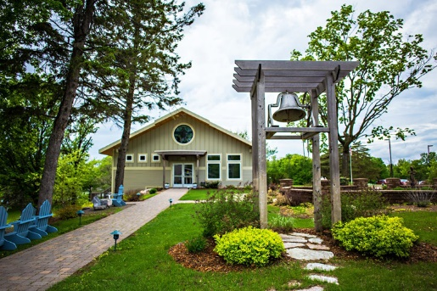

**Discipleship Retreat: April 22, 23 & 24, 2022**

Join us at Mount Carmel Bible Camp in Alexandria, MN for our annual discipleship retreat. Cost is $160 per person double occupancy and $199 per person single occupancy. Includes two nights of lodging and 5 meals. Sign up at the Welcome Center by March 20 and indicate if you would like a cabin or a lodge room.

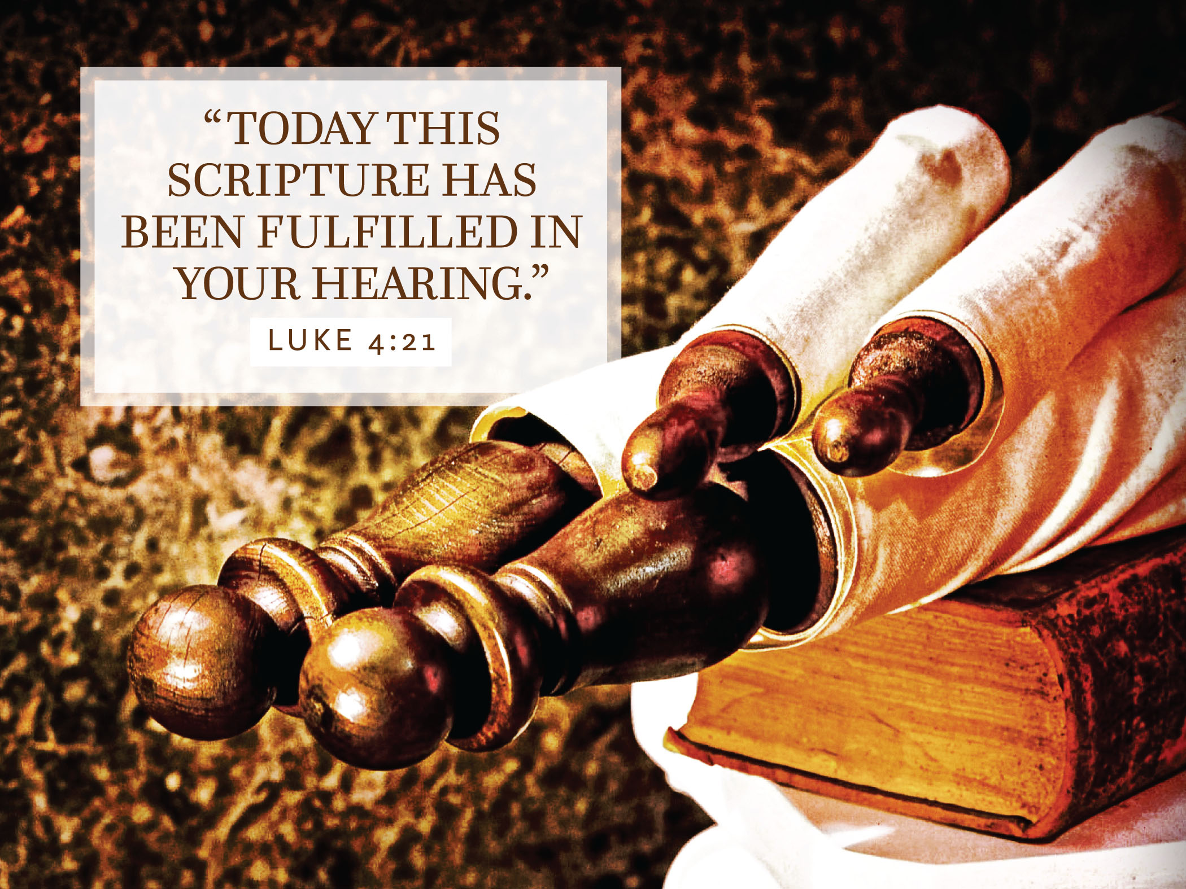

**January 23, 2022**

**Worship at 8:00, 9:00 & 10:15 am**

**All Saints Lutheran Church**

**511 Merger Street, P.O. Box 550**

**Norwood Young America, MN 55368**

**952-467-3388**

[**www.allsaintsnya.org**](http://www.allsaintsnya.org)