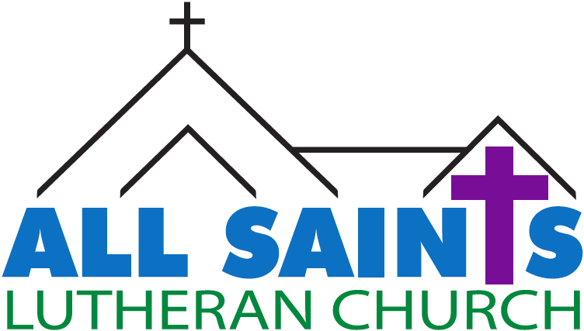

Pastor Matt Schroeder, Senior Pastor
Pastor Paul Papanek Stork, Interim
Darcy Gray, Office Administrator
Patrick & Jacqueline Bencke, Missionaries – Japan ___________________________________________________________________
Midweek Lent Worship March 29, 2023 6:30 pm

Prelude

Welcome

Greeting
L: The Lord be with you.
C: And also with you.

Gathering Song “White as Snow”

Verse
White as snow white as snow
Though my sins were as scarlet
Lord I know Lord I know
That I'm clean and forgiven

Chorus
Through the power of Your blood
Through the wonder of Your love
Through faith in You I know
That I can be white as snow

CCLI Song # 491917
Leon Olguin
© 1990 Sound Truth Publishing (Admin. by Brentwood-Benson Music Publishing, Inc.)
Universal Music - Brentwood Benson Publishing (Admin. by Brentwood-Benson Music Publishing, Inc.)
For use solely with the SongSelect® Terms of Use. All rights reserved. www.ccli.com
CCLI License # 968550

Greeting from Mr. Tumnus – “Deeper Magic From Before the Dawn of Time”

Reading Romans 3:21-26

21 But now, irrespective of law, the righteousness of God has been disclosed, and is attested by the law and the prophets, ²²the righteousness of God through faith in Jesus Christ for all who believe. For there is no distinction, ²³since all have sinned and fall short of the glory of God; ²⁴they are now justified by his grace as a gift, through the redemption that is in Christ Jesus, ²⁵whom God put forward as a sacrifice of atonement by his blood, effective through faith. He did this to show his righteousness, because in his divine forbearance he had passed over the sins previously committed; ²⁶it was to prove at the present time that he himself is righteous and that he justifies the one who has faith in Jesus.

L: The Word of the Lord
C: Thanks be to God

Sermon Pastor Matt Schroeder

Offertory Anthem “Journey for Home” Contemporary Worship Team

Solo: In our weakness were made strong
In our suffering were made stronger

All: We live and journey, journey for home

Solo: In the dark we turn to the light.
In our faith you heal our blindness

All: We live and journey, journey for home

All: (Refrain)
And may we glorify your name as we renew our love each day
Lord, make us strong in hope and faith we sing to you.
For it is you who draws us here, Our Lord, Messiah, always near
We live and journey, journey for home

Solo: Though our hearts be burdened with sin
through your love you brought us salvation.

All: We live and journey, journey for home

Solo: Through the gifts and love that we share
we will know your presence among us.

All: We live and journey, journey for home.

(Refrain) 2x

We live and journey, journey for home

Contributor: Ed Bolduc
Copyright © 1996, World Library Publications
Reprinted with permission under ONE LICENSE No. A-726537. All Rights Reserved

The Prayers
L: God of power and might, in this fifth week of Lent, we pray you renew in us the gifts of your love, grace, and mercy. Increase our faith, strengthen our hope, enlighten our understanding, widen our charity, and make us ready to serve you; through Jesus Christ our Lord, who lives and reigns with you and the Holy Spirit, one God, now and forever.
C: Amen.

L: Lord, remember us in your kingdom and teach us to pray.
All: Our Father, who art in heaven hallowed be thy name.
Thy kingdom come, Thy will be done on earth as it is in heaven
Give us this day our daily bread; and forgive us our trespasses
As we forgive those who trespass against us; And lead us not into temptation,
but deliver us from evil. For thine is the kingdom, and the power
And the glory forever and ever. Amen.

Blessing
L: Almighty God, Father, Son, and Holy Spirit, bless you now and forever.
C: Amen.

Sending Hymn “On That Holy Mountain”

(Verse 1)
S: The wolf is the guest of the lamb,
C: on that holy mountain.
S: And the calf and the lion shall lie down,
C: on that holy mountain.
S: Together they shall rest with the child,
C: on that holy mountain, on that holy mountain,
on that holy mountain of the Lord.

All: (Refrain)
No harm or ruin on that holy mountain.
That sacred day shall be filled with knowledge.
There shall be peace, led by all the children,
on that holy mountain, on that holy mountain,
on that holy mountain of the Lord.

(Verse 2)
S: The poor shall receive from the rich,
C: on that holy mountain.
S: And the sick and the lame shall be healed,
C: on that holy mountain.
S: Together they shall rest with the child,
C: on that holy mountain, on that holy mountain,
on that holy mountain of the Lord.

(Refrain)

(Verse 3)
S: Justice shall flowr for all time,
C: on that holy mountain.
S: As long as the sun still can shine,
C: on that holy mountain.
S: Peace till the moon be no more,
C: on that holy mountain, on that holy mountain,
on that holy mountain of the Lord.

(Refrain)

Holy and peaceful the day of the mountain.

CCLI Song # 3022544
Joe Mattingly
© 1990 World Library Publications (Admin. by G.I.A. Publications, Inc.)
For use solely with the SongSelect® Terms of Use. All rights reserved. www.ccli.com
CCLI License # 968550

L: Go in peace. Serve the Lord.
C: Thanks be to God.

WELCOME TO ALL SAINTS

We are glad you chose to worship at All Saints today. We hope you find the worship service meaningful and that you feel at home with our congregation. If you want to learn more about All Saints or are looking to be connected, visit www.allsaintsnya.org or contact one of our staff:
Darcy Gray, Office Administrator dgray@allsaintsnya.org
Pastor Matthew Schroeder, Senior Pastor mschroeder@allsaintsnya.org
Pastor Paul Papanek Stork, Interim pstork@allsaintsnya.org

Wed Mar 29 3:00 pm WOW (Last Day)
4:30 pm Children's Choir (Last rehearsal)
5:30 pm Confirmation large group
6:30 pm Lent Worship
7:00 pm All Saints Choir

Thur Mar 30 3:00 - 5:00 pm Fare for All
6:00 pm Back to Basics at Northside Grill

Sat Apr 1 8:00 am Men's Fellowship at Hillcrest
8:00 am Women's Fellowship at church

Sun Apr 2 Palm Sunday Worship and Communion at 8 & 9:30 am
9:30 am Sunday School class and sing in worship

Wed Apr 5 No Activities

March is Food Shelf month
Please bring in food or dry good donations and place in the black crates by the front entrance. Thank you for supporting the local community food shelves.

Fare For All is a program where anyone can shop for fresh, quality, and affordable groceries. Fare For All buys fresh produce and frozen meat from bulk wholesalers and growers, bundles them into $10-$30 packages, and distributes them at pop-up sites around the cities.
All Saints has joined 30+ sites in the Twin Cities and Greater MN area for the year 2023. Upcoming sale dates are: March 30, May 4, June 1, August 3, September 7, October 5, November 28 from 3-5pm. Volunteer sign up can be found at the Welcome Center. More information can be found at: https://www.thefoodgroupmn.org/groceries/fare-for-all/

Back to Basics
All Saints’ young adult group “Back to Basics” is meeting at Northside Grill on Thursday March 30 at 6:00 pm. We’ll be talking about a question we all struggle with as we get closer to Good Friday: why did Jesus have to die?

Upcoming Worship Schedule
April 2 - Palm Sunday Worship and Communion at 8:00 & 9:30 am

April 6- Maundy Thursday General Worship at 6:30 pm
First Communion Student and Family Worship at 7:30 pm

April 7 - Good Friday Worship at 6:30 pm
April 9 - Easter Sunday Worship at 7:00, 8:00 & 9:30 am
April 16 - Worship at 8:00 am
9:30 am Confirmation Service

April 23 - Worship at 8:00 & 9:30 am
Blessing of the Graduates at 9:30 am
10:30 am Graduation Banquet in Fellowship Hall

Senior High Graduation Banquet
On Sunday, April 23 we will have a Graduation Banquet Event beginning at 9:30 am in worship at which you will be recognized and receive a laying on of hands blessing. Then we will continue with a meal in your honor at 10:30 am in the Fellowship Hall. What can you expect at this event: A baby picture guessing contest (please email a baby photo to Pastor Matt at mschroeder@allsaintsnya.org; Encouragement to keep the faith as your journey into the world; receive a special gift from All Saints, enjoy a delicious meal, fellowship with classmates and their families. Please mark this date on your calendars now and plan to attend. Who is invited? The graduating senior, his/her parents, siblings, and grandparents. Please RSVP by Sunday, April 9 and let us know how many from your family are coming. Please have accurate numbers since this is a catered meal that we pay for. You can call the church at 952- 467-3388 or email Darcy dgray@allsaintsnya.org

Discipleship Retreat: April 28, 29 & 30, 2023
Join us at Mount Carmel Bible Camp in Alexandria, MN for our annual discipleship retreat. Cost is $180 per person double occupancy and $219 per person single occupancy. Includes two nights of lodging and 5 meals. Sign up at the Welcome Center by April 2.

Thrivent Event at All Saints: Savvy Social Security
Join Thrivent and Henke Hess Financial Group as they cover these common questions: When should I file for Social Security benefits? If I file and continue to work, how will my benefits be affected? Will I pay taxes on my Social Security benefits? Don’t miss out on potential opportunities to maximize your retirement income!
Tuesday, May 2 at 2:00 pm or 6:00pm. Reserve your space today by calling Jessica at 952-442-8461 or email jessica.hess@thrivent.com.

"Stellar"
Vacation Bible School
June 12- 15, 2023
9:00-11:30 a.m.
For kids age 4 (as of time of registration)
and Kindergarten to Grade 6 (entering fall 2023).
Cost is $18 per child with a $36 family max. Scholarships are available.
Register at www.allsaintsnya.org
Registration forms also at Welcome Center

Current Grade 7 - Adult: If you are interested in helping with VBS this year please sign up at the Welcome Center or let Darcy know.

Available volunteer positions:
Classroom Teacher
Classroom Helper
Assist with games
Assist with crafts
Kitchen/Snacks
Transportation driver
Floating Helper
Music/VBS Band
Photographer

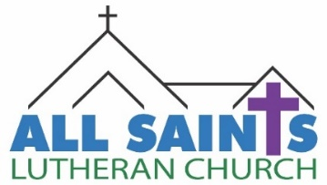
Online Giving at All Saints:
Visit www.allsaintsnya.org or scan the QR code to set up a one time or recurring donation using your debit/credit card or checking/savings account.

All Saints Lutheran Church
511 Merger Street, P.O. Box 550
Norwood Young America, MN 55368
952-467-3388
allsaintsnya.org

