Heart of Ezra Ministries Report and Testimonies

Simeone is the Worship Leader and the pastor’s son of the Chiesa Cristiana Cristo Regna (Christ Reigns Christian Church) in Naples. For many years we have a class in this church and the pastor asked for either me or Michela to come once a month to start the class and then his wife will conduct it. Following is a brief message I received from Simeone when I was in Naples at the end of March.
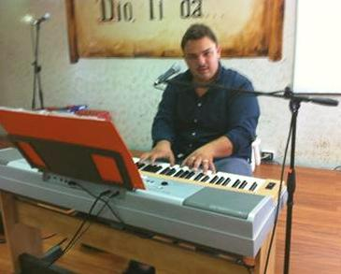
“Hello Pastor, I wanted to thank you for everything that, through your Bible studies, the Lord is giving to my life. Thank you because it is an honor to be with you when you come to our church every month and the blessings of God we receive and enjoy through the class. I wanted to tell you and that you and Heart of Ezra Ministries blessed my life. Thank you especially for last Sunday’s opportunity to receive the wonderful Word you preached in the our church. May God continue to bless you and your wonderful ministry.”

In the same church miracles are happen each time we have a class. Among the 28-30 students are three women (I am unable to show any photos...you can understand why as you read this story). The unique thing about these women is that they are all wives of Mafia bosses, different gangs and against each others, but they faithfully put aside rivalry and come to class to study the Word of God that is producing a real fruit in their lives. Pina is one of the three and her husband has been in jail for the last 20 years and still runs the “business”. She receives a monthly salary from this business of about 50.000 Euro monthly ($65,000.+ US), … but since she was confronted by the Word of God and received Christ as her Savior and Lord, she refused to use that money. Instead, she found a job and currently works to support herself and her two children.
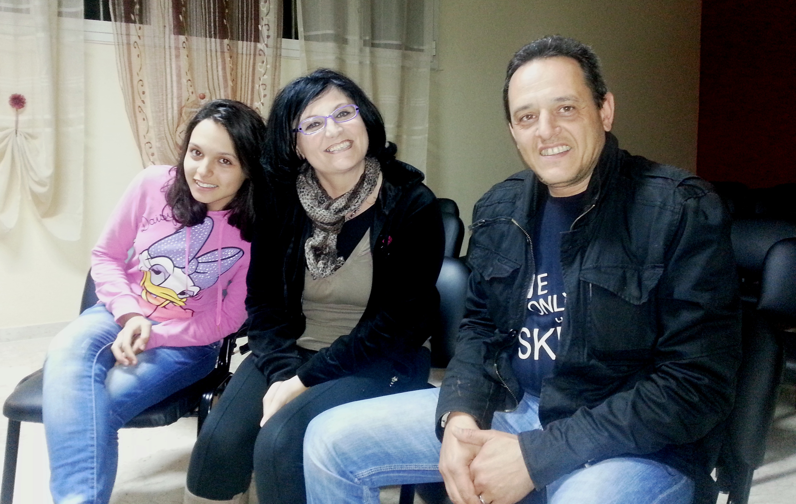
We met Nicolas, Olga and Ilona two months ago during a pastor’s meeting in Trapani. A friend invited them to come for the evening service and when they heard that we teach a Bible class not far from their home, they decided to give it a try. Nicolas and Olga both came from divorces and are actually living together; Ilona is Nicolas’ daughter. It is wonderful how the Word of God pierced the hearts of all the family!!! They all asked to be baptized, and most important, Olga and Nicolas decided to get marry after 5 years of living in sin. They became our most faithful students of one of the classes we have in Marsala, and just last week, we were invited to a special dinner where Olga and Nicolas invited their former husband and wives together with their new partners to ask for their forgiveness and reestablish relationships between their new families!! This is a miracle!!!

Pina and Onofrio are a dear elderly couple that opened their house to start a Bible class. Pina had been a believer for over 15 years even though she never attended a church while her husband Onofrio never became a believer, but rather, hated the evangelical church, For some reason, however, (and we know Who IS the reason) Onofrio accepted us (Precept) in his home to study the Word. Pina invited all her friends and relatives from the neighborhood. During the first meeting Michela had 15 women attending the class, Onofrio being the only male. Sitting on the couch, Onofrio was listening but not participating to the discussion, but, … “the walls of Jericho” were already trembling! The third time Michela held the class, she asked if Onofrio if he would like to sit with them at the table. Out of courtesy he accepted. During the discussion Michela felt in her heart to ask Onofrio to read some Bible verses from the manual and, as he read, tears began to flow down his face. He kept on reading but could not stop crying. At the end of the meeting Michela asked Onofrio if he wanted to pray and ask Jesus in his heart In tears, he bowed his head and wonderfully asked the Lord to forgive his sins and be his Saviour!!! Hallelujah!!! Onofrio asked to be baptized and both he and Pina are attending our church in Marsala and are becoming examples to the youngest. Now, they never miss a service, prayer meeting or a Bible study class. The church in Marsala is a result of our Bible study classes while every member of the congregation had been saved through the ministry of classes held here in the last three years.
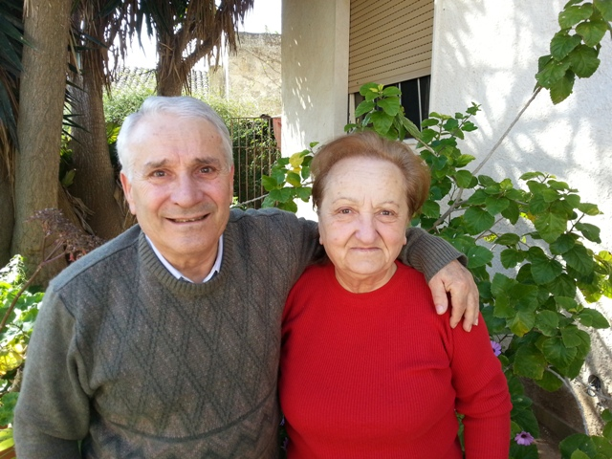

Giuseppe Capuano and his wife Julie are part of our mission team. They started a Bible class in a small town called Città della Pieve, where there are no churches in the area; it was a pioneer enterprise. People began showing interest in the Word as they faithfully held their class in town. One by one, people attending the class became aware of their need for a relationship with the Lord and asked Giuseppe to pray for them as they repented from their sin, giving their hearts and lives to God. He held a baptism service with six people and a new church is now established as a result of the Precept class started in that small town. Following is a brief report from their last newsletter.
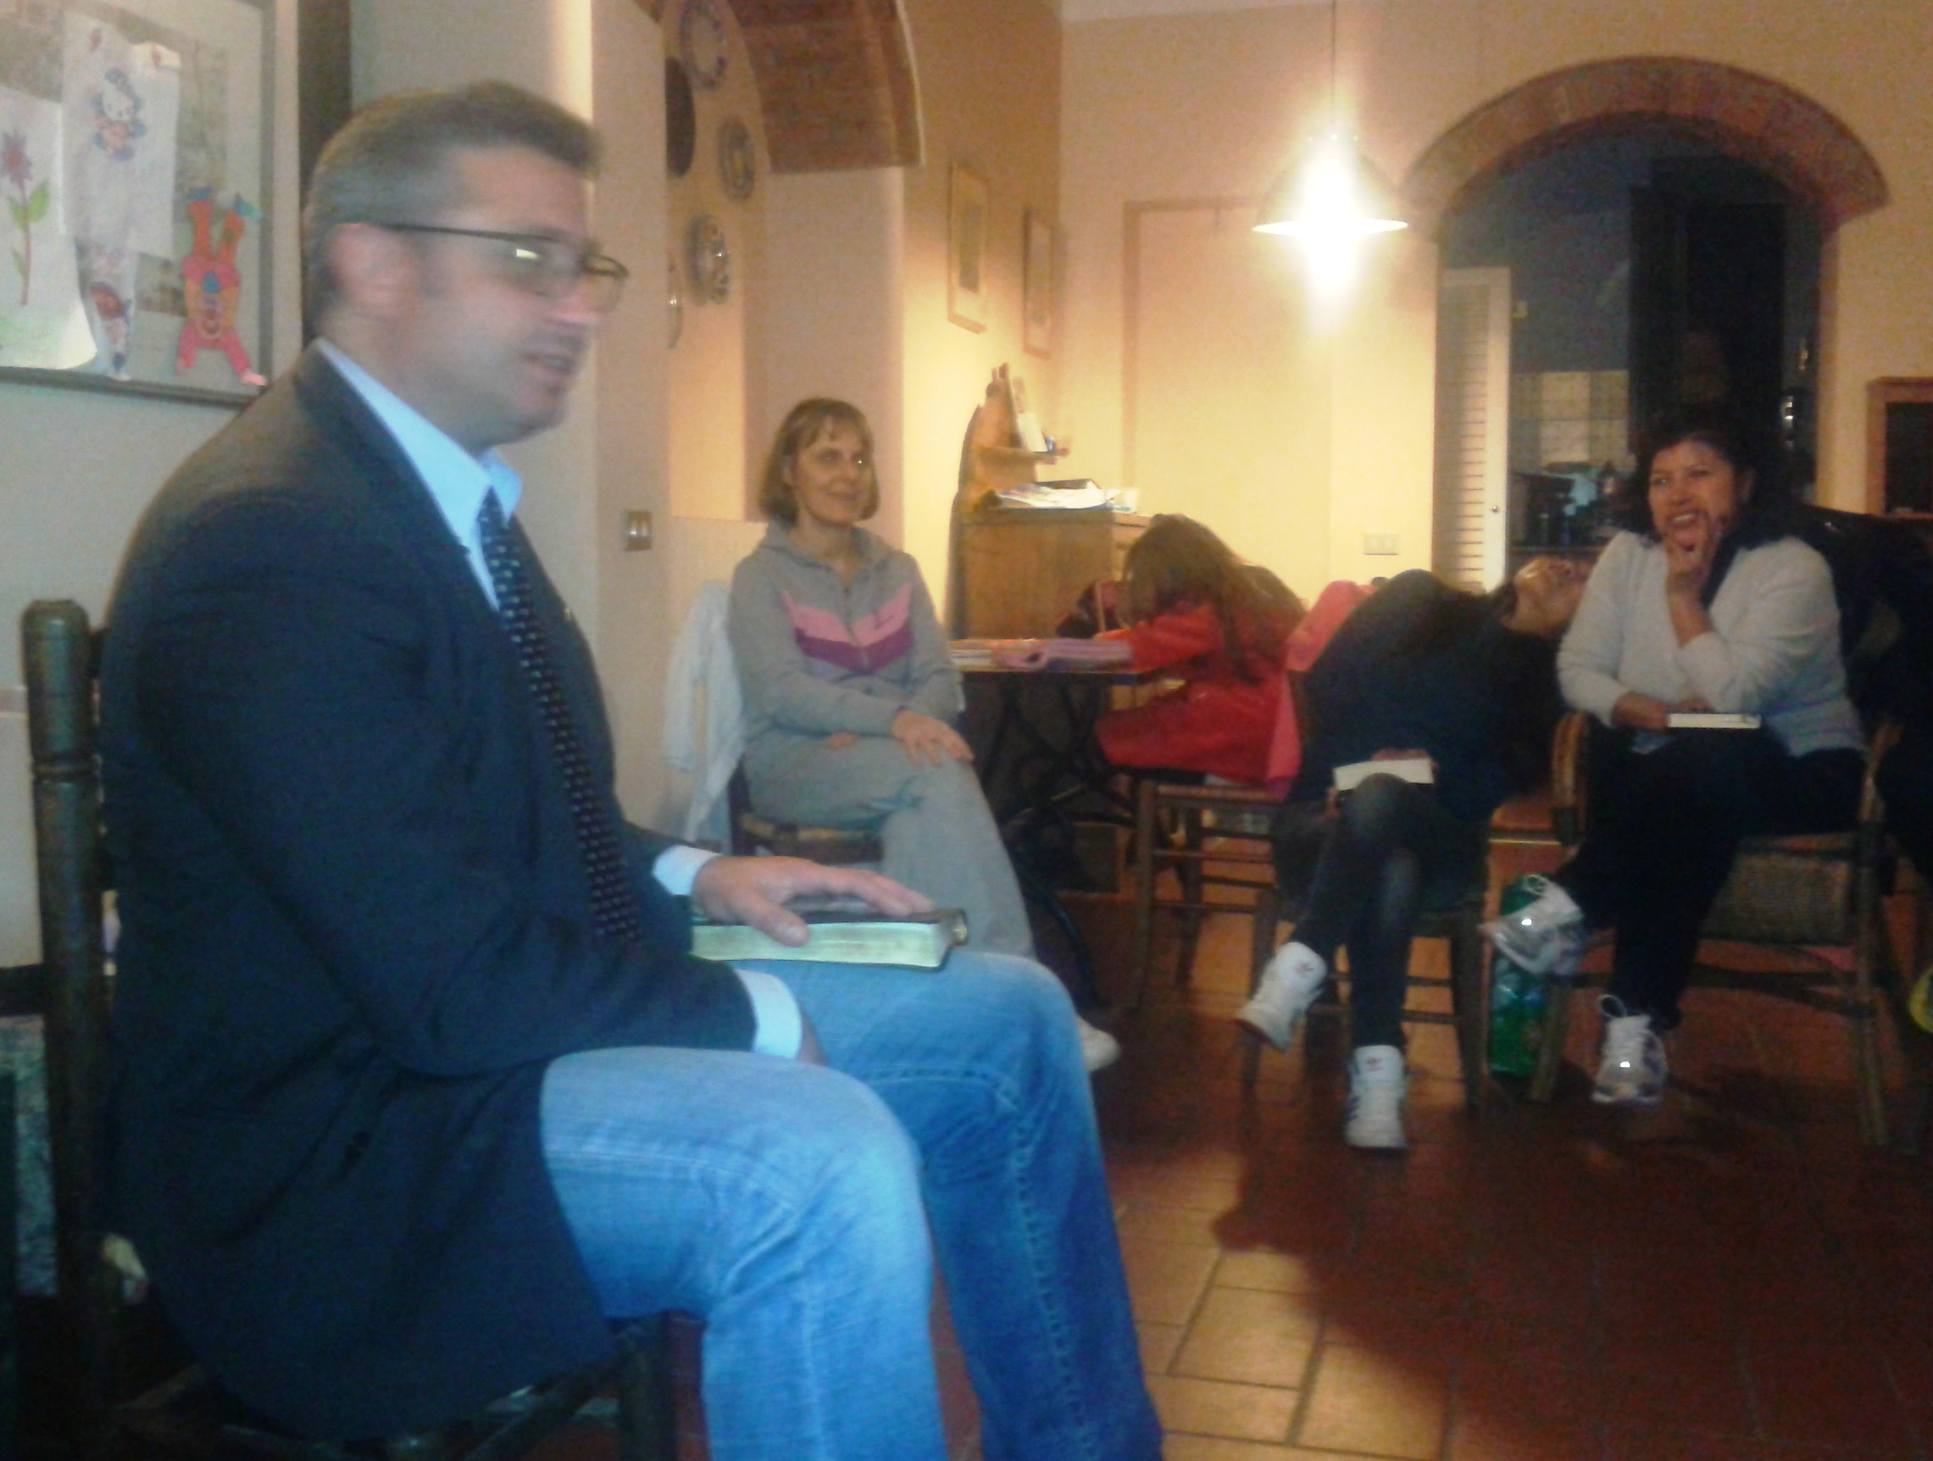
“This letter, in particular, is a request for earnest prayer for our church here. The persecution we are going through since opening this new centre is intensifying each day. Each and every person in the church is suffering in some way due to the slander being put around the town ( initiated by the local priest). As I mentioned in my last letter, the lady who had just began attending before Christmas was “scared off” by the threat of being thrown out of her home if she continued. Her home is rented very cheaply from the priest and she only receives 500 Euros monthly from her pension prohibiting other accommodation. Praise God she is slowly beginning to return and has called in for a chat several times and attended a few meetings. Please continue to pray for her as she lives alone and her only son is totally against her being here.”
Heart of Ezra Ministries is becoming an example of church planting throughout the country. God has already established four churches through this ministry in different cities. Praise Him!!
Luigi and Michela

